1. Lago di Braies

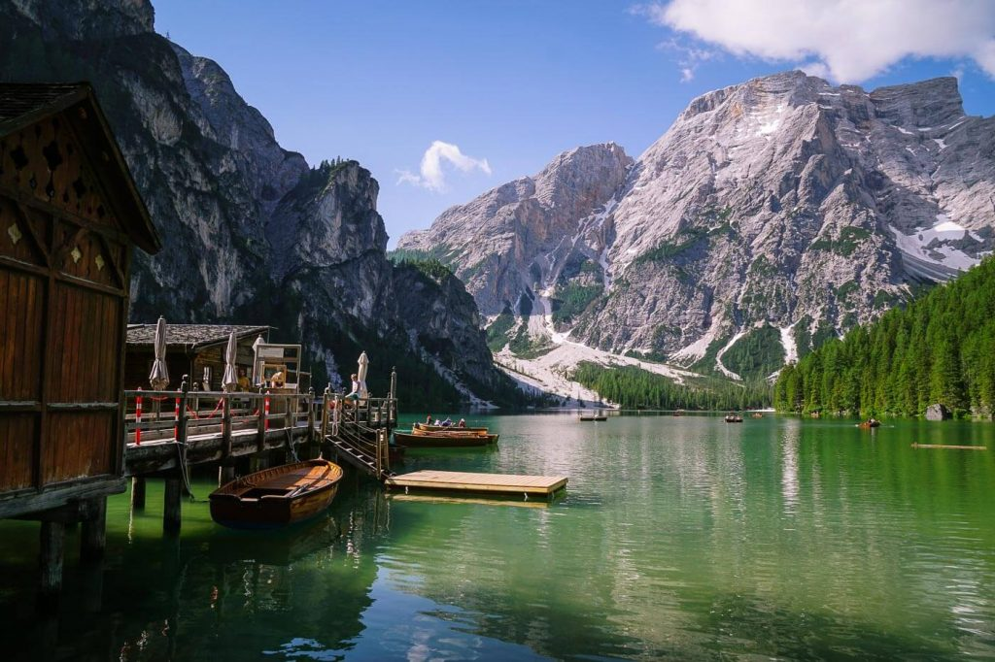

stunning, circuit,

[Lago di Braies](https://www.moonhoneytravel.com/lago-di-braies-italy/)(Pragser Wildsee) is a …stunning………………..lake at the foot of Croda del Becco/Seekofel in Valle di Braies/Pragser Tal, a side valley of Alta Pusteria/Pustertal in South Tyrol.

The best time of year to visit Lago di Braies is early in the summer (June) or in the fall (late September – October). As the summer season progresses, the water level decreases.

Lago di Braies is usually the first place people want to see in the Dolomites. In high season, it’s a zoo. Most people just come for the photo. Many will walk the …circuit………………… trail around the lake. But, the smartest people visit Lago di Braies at sunrise and hike to the summits of surrounding peaks, like [Hochalpenkopf](https://www.moonhoneytravel.com/hochalpenkopf-cima-dei-colli-alti-hike-dolomites/).

Did you know that Lago di Braies is the starting point of the [Alta Via 1](https://www.moonhoneytravel.com/europe/italy/dolomites/alta-via-1-hike/)long distance trail?

2. Prato Piazza

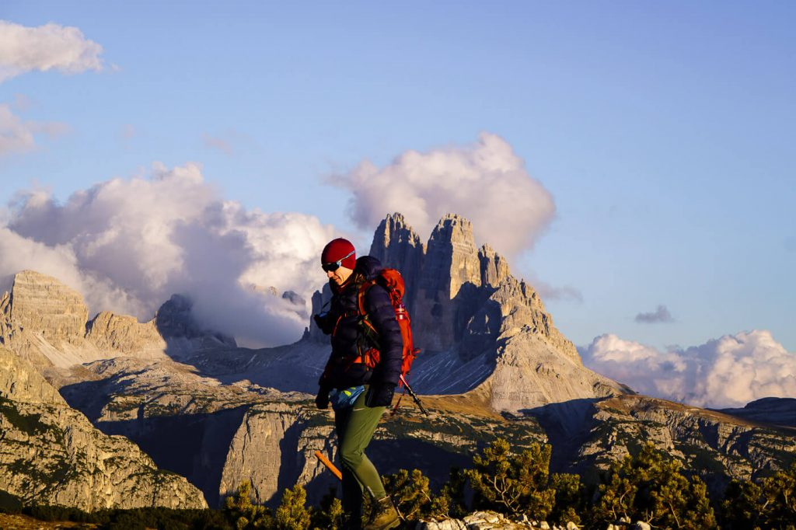

**pasture, marvelous, panoramic**

[Prato Piazza](https://www.moonhoneytravel.com/prato-piazza/) (Plätzwiese) plateau is a high alpine …pasture………………. above Valle di Braies/Pragser Tal, not too far from Lago di Braies. The plateau lies between Picco di Vallandro/Dürrenstein (2839 m) and Monte Croda Rossa d’Ampezzo/Hohe Gaisl (3146 m) in Fanes-Sennes-Braies Nature Park.

The best thing to do on Prato Piazza is hike the …marvelous……………. summit of [Monte Specie/Strudelkopf.](https://www.moonhoneytravel.com/monte-specie-strudelkopf/) From this easy-to-reach peak, you’ll be treated to …panoramic…………………….. views of Tre Cime di Lavaredo, Cadini di Misurina, and the Cristallo Group.

3. Val Fiscalina

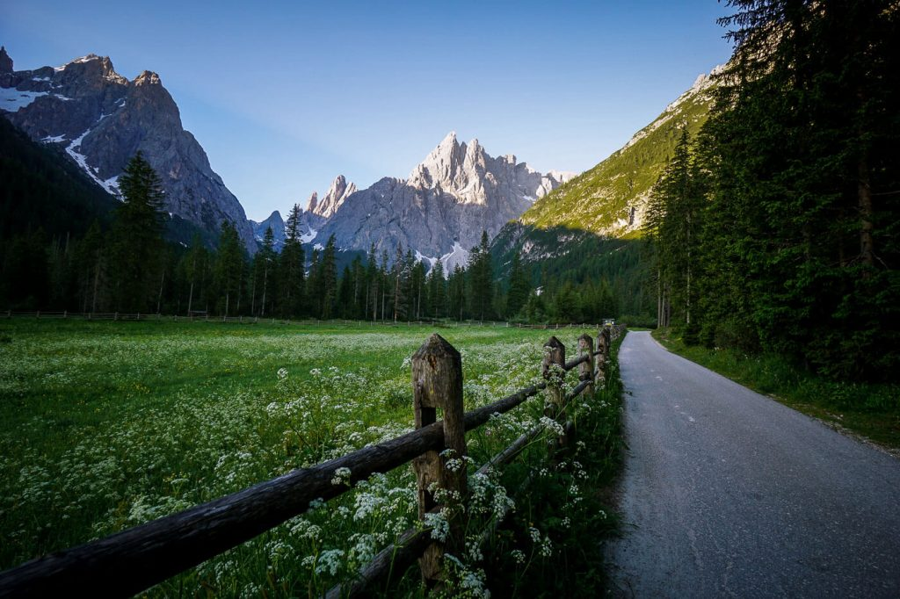

**gorgeous, ascending, refuge, gateaway**

Val Fiscalina/Fischleintal is a …gorgeous…………………. side-valley of Sesto/Sexten Valley in South Tyrol. It serves as a …refuge………………….. to the northern [Sexten Dolomites](https://www.moonhoneytravel.com/sesto-sexten-dolomites-hiking-trails/) and the Three Peaks Nature Park.

For a low-key adventure, hike the Val Fiscalina valley trail, starting at Bad Moos and ending at Rifugio Fondovalle/Talschlusshütte.

From this valley …gateaway…………………, you can continue …ascending………………… Valle Sasso Vecchio/Altensteintal valley all the way up Rifugio Locatelli/Dreizinnenhütte (2405 m) and Tre Cime di Lavaredo/Drei Zinnen. That’s how we started this easy-moderate [3-day hut-to-hut hike](https://www.moonhoneytravel.com/europe/italy/dolomites/trekking-tre-cime-di-lavaredo/).

There are two excellent hotels in Val Fiscalina you should know about: [Bad Moos Dolomites Spa Resort](https://www.booking.com/hotel/it/sport-kurhotel-bad-moos.en.html?aid=1433540&no_rooms=1&group_adults=2&room1=A%2CA) and the historic [Hotel Dolomitenhof](https://www.booking.com/hotel/it/dolomitenhof.en.html?aid=1433540&no_rooms=1&group_adults=2&room1=A%2CA).

4. Alpe di Siusi

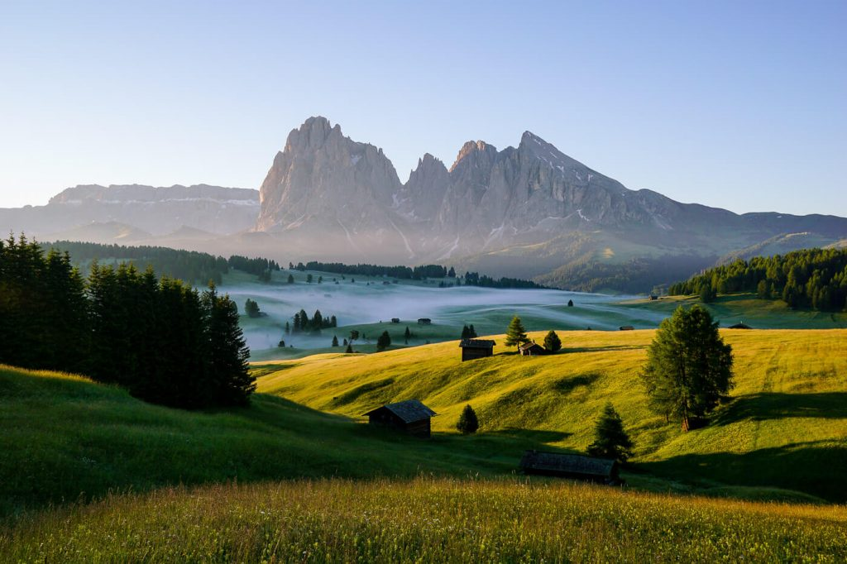

rolling, fraught, gourmet, exhilarating,

Alpe di Siusi (Seiser Alm in German, Mont Sëuc in Ladin) is the largest high-alpine pasture in Europe, covering a surface area of 56 square kilometers. This …exhilarating………………………alpine plateau stretches from the foot of the Sassolungo Group (Langkofel) to the base of Sciliar (Schlern) in South Tyrol.

Alpe di Siusi is a magnet for photographers as well as hikers, cyclists, and skiers. You can access the plateau easily by gondola from both [Ortisei](https://www.moonhoneytravel.com/ortisei-val-gardena-italy/) in Val Gardena as well as Siusi allo Sciliar. We’ve explained all the details of how to get here in our [Alpe di Siusi Travel Guide](https://www.moonhoneytravel.com/alpe-di-siusi-seiser-alm-italy/)**.**

The entire pasture is …fraught……………………….. with alpine pasture huts (Alm/Malga/Schwaige), which are perfect destinations for lunch. Drop by [Gostner Schwaige](https://www.aussergost.com/en/gostner-schwaige/) for homemade dairy products, [Rauchhütte](http://rauchhuette.com/) for wine and [Malga Sanon](https://www.sanon.it/) for local cuisine.

If you visit during the summer season, we recommend hiking this …rolling…………………… [Alpe di Siusi – Rifugio Bolzano – Rifugio Alpe di Tires circuit trail](https://www.moonhoneytravel.com/alpe-di-siusi-rifugio-bolzano-hike-dolomites/). This 21.6 km circuit takes about 8 hours to complete.

We hiked this route during our stay at [Hotel Steger-Dellai](https://www.booking.com/hotel/it/steger-dellai.en.html?aid=1433540&no_rooms=1&group_adults=2&room1=A%2CA) on Alpe di Siusi. This traditional hotel is located directly on the Hans and Paula Steger Trail, very close to Gostner Schwaige and not too far from Compaccio/Compatsch (15 minute walk). Staying on Alpe di Siusi is an unforgettable experience. You can take sunrise and sunset walks, hop between …gourmet……………………… alpine pasture huts, and undertake longer hikes like the Rifugio Bolzano circuit.

5. Seceda

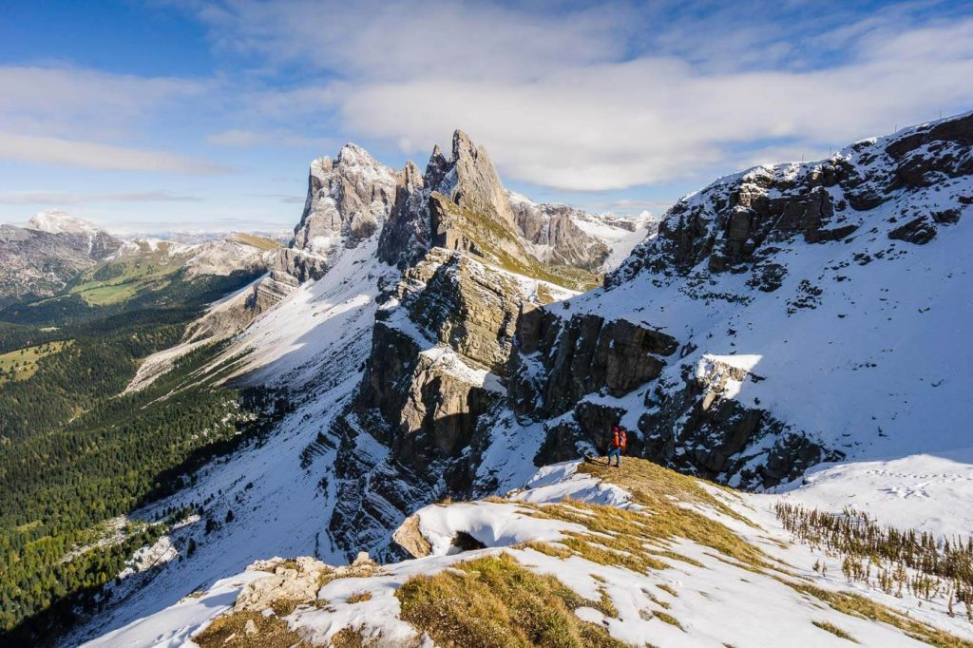

**staggering, ridgeline, cableway, slashing,**

Seceda is a mountain in the Odle/Geisler Group situated within the[Puez-Odle Nature Park](https://www.moonhoneytravel.com/puez-odle-nature-park-dolomites-italy/) in South Tyrol.

The summit of Seceda (2518 meters) is one of the top places to visit in the Dolomites because of its …staggering…………………. view of the Odle/Geisler peaks. From this perspective, the Odle pinnacles look like a set of knives, …slashing……………………….the sky.

The easiest and fastest way to get to Seceda is by …cableway……………………. from Ortisei. From the Ortisei-Furnes-Seceda mountain station, it’s a 10 minute walk to the summit viewpoint.From here, we suggest following the …ridgeline……………………………. towards the peaks and hiking this [Seceda to Rifugio Firenze circuit trail](https://www.moonhoneytravel.com/hiking-seceda-regensburger-hutte-val-gardena/)(3:00 – 3:30 hours).

If you want to skip the expensive cableway ride, you can hike to Seceda from Val Gardena on this [Monte Pic hike](https://www.moonhoneytravel.com/monte-pic-hike-val-gardena-dolomites/).

Experienced hikers may want to approach Seceda from Resciesa Plateau and the Mittagscharte on this [Resciesa – Seceda day hike](https://www.moonhoneytravel.com/resciesa-rifugio-malga-brogles-seceda-ortisei/).

6. Val di Funes

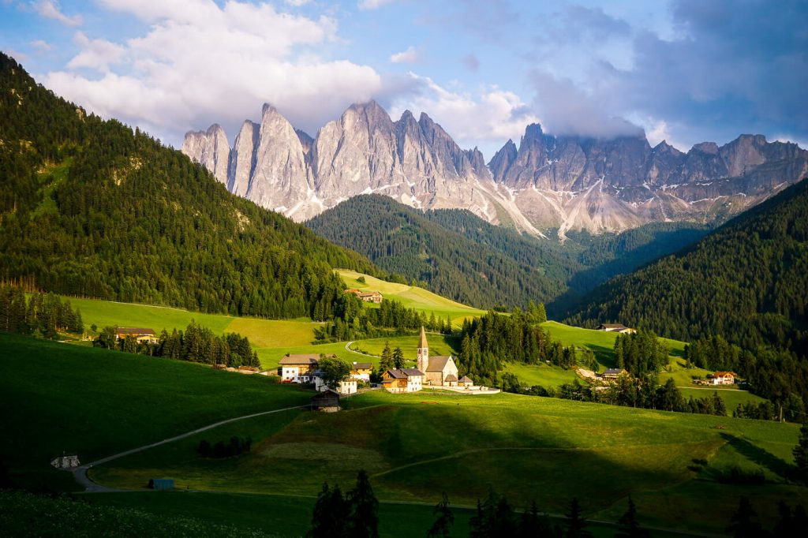

**idyllic, roaring, hike,**

[Val di Funes/Vilnösstal](https://www.moonhoneytravel.com/val-di-funes-dolomites-italy/) is an …idyllic……………………… valley, which runs from Valle Isarco/Eisacktal Valley to the Odle/Geisler mountain range.

No place can rival the fairytale beauty of Val di Funes. Here, the …roaring……………………..Odle/Geisler peaks jut out of a picture-perfect pastoral landscape of rolling pastures and forest.

For the best view of Val di Funes, head to the village of Santa Maddalena and follow this [panorama trail](https://www.moonhoneytravel.com/santa-maddalena-val-di-funes-panorama-trail/)above the Santa Maddalena Church.

The most popular …hike…………………. in Val di Funes is the [Adolf Munkel Trail](https://www.moonhoneytravel.com/hiking-adolf-munkel-trail-dolomites/) to Geisler Alm. A quieter alternative is the [Rifugio Genova circuit trail](https://www.moonhoneytravel.com/rifugio-genova-val-di-funes-hike/).

Our personal favorite hike is the summit of [Tullen,](https://www.moonhoneytravel.com/tullen-peak-hike-odle-d-eores-dolomites/) the highest peak in the Odle d’Eores/Aferer Geisler Group.

Most people make the mistake of only visiting Val di Funes for a few hours. We highly recommend staying at least 2-3 nights. The best places to stay are  [Fallerhof](https://www.booking.com/hotel/it/fallerhof-st-magdalena.en.html?aid=1433540&no_rooms=1&group_adults=2&room1=A%2CA) (budget), [Hotel Fines](https://www.booking.com/hotel/it/hotel-fines.en.html?aid=1433540&no_rooms=1&group_adults=2&room1=A%2CA) (midrange), or [Hotel Tyrol](https://www.booking.com/hotel/it/tyrol-funes.en.html?aid=1433540&no_rooms=1&group_adults=2&room1=A%2CA) (luxury) in Santa Maddalena.

7. Passo delle Erbe

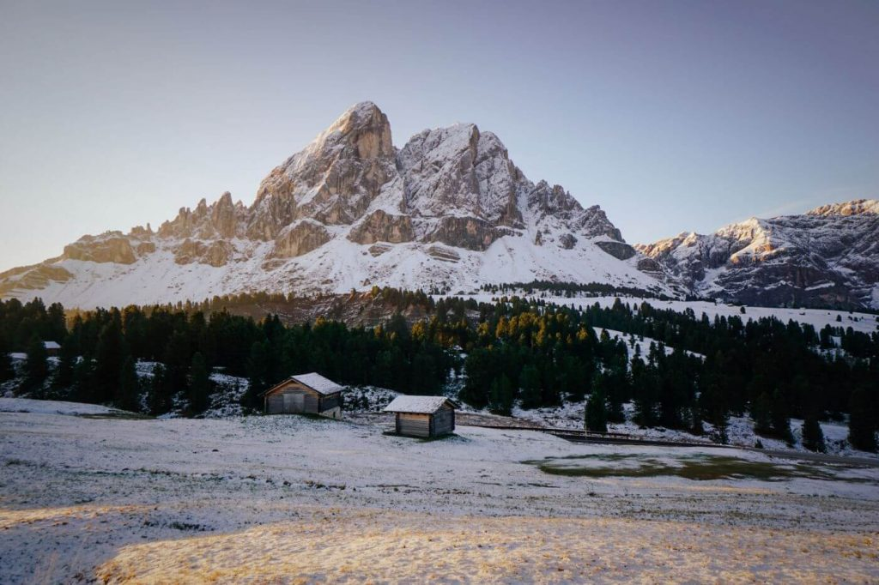

**pass, imposing, familiarity, overlook, leg, overnight,**

Passo delle Erbe (Würzjoch in German, Ju de Börz in Ladin) is a mountain …pass…………………. that connects San Martin de Tor in Val Badia with Val di Funes and the city of Brixen in the Eisacktal. This high mountain pass (2206 m) lies between the …overlook…………………….. Sass de Putia/Peitlerkofel mountain and Monte Muro/Maurerberg.

Directly at the pass, you’ll find [Ütia de Börz](https://www.booking.com/hotel/it/utia-de-borz.en.html?aid=1433540&no_rooms=1&group_adults=2&room1=A%2CA), a lovely refuge-hotel and delicious restaurant. This is a fantastic place to stay if you want to …overnight………………….. in the mountains, but you don’t want to sacrifice any comfort. The bedrooms …imposing………………….. the pass and Sass de Putia. We loved staying here.

The best thing to do at Passo delle Erbe is to hike the [circuit trail around the two-headed Sass de Putia](https://www.moonhoneytravel.com/sass-de-putia-circuit-hike-dolomites/). This 12.8 km trail takes about 4 hours.

You can extend this hike to the summit of Sass de Putia, which is a lot of fun. The final…leg…………………. to the summit is protected. It’s not difficult, but you should have a head for heights and some …familiarity……………………… with secured routes. Bring your climbing gloves.

* **Recommended climbing gloves:**[**Black Diamond Crag Half-Finger Gloves**](https://amzn.to/2UGM69g)

There’s a parking lot at the pass. In summer, you have to pay a small fee to park here. In fall, there’s no fee.

8. Passo Gardena

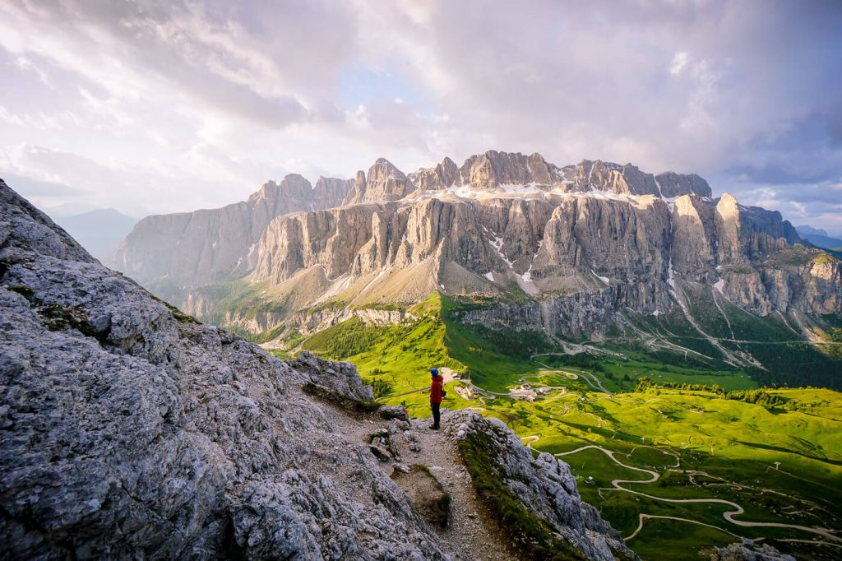

Passo Gardena (Grödner Joch in German, Ju de Frara or Jëuf de Frea in Ladin) is the stunning mountain pass that connects Val Badia with Val Gardena. It lies between the Sella Group and the Cir Group.

Passo Gardena (2136 m) is also an exciting trailhead. From the Gardena pass, you can hike to the summits of [Gran Cir](https://www.moonhoneytravel.com/gran-cir-via-ferrata-dolomites/) and [Cima Pisciadu](https://www.moonhoneytravel.com/cima-pisciadu-lake-hike-dolomites-italy/).

There are several paid parking lots at Passo Gardena and a hotel ([Hotel Cir](https://www.booking.com/hotel/it/cir-selva-gardena.en.html?aid=1433540&no_rooms=1&group_adults=2&room1=A%2CA)).

If you’re hungry, walk 15 minutes to Rifugio Jimmy/Jimmyhütte.

9. Puez-Odle Nature Park

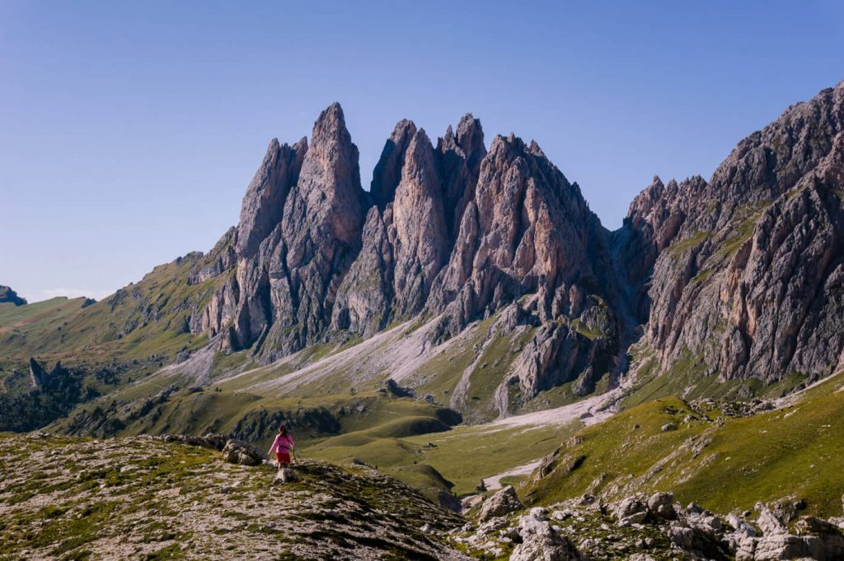

**encompasses, overlooked,**

[Puez-Odle Nature Park](https://www.moonhoneytravel.com/puez-odle-nature-park-dolomites-italy/) (Naturpark Puez-Geisler) is a protected park in South Tyrol. It …encompasses……………………. some of the best known mountains in the Dolomites including the Odle/Geisler Group, Odle d’Eores/Aferer Geisler, Sass de Putia/Peiterkofel, Puez Group, and the Cir Group.

You can access the park from Passo delle Erbe, Val d’Eores/Aferer Tal, Val di Funes, Val Gardena, Passo Gardena, and Val Badia.

Beyond the obvious places to see (e.g. Seceda), there are so many …overlooked……………………….. destinations in the park which are worth visiting, including the [Gherdenacia/Gardenaccia plateau](https://www.moonhoneytravel.com/rifugio-puez-hike-puez-odle-dolomites/) and the [Stevia Alpine Pasture](https://www.moonhoneytravel.com/rifugio-stevia-col-dala-pieres-valgardena-dolomites/).

10. Armentara Meadows

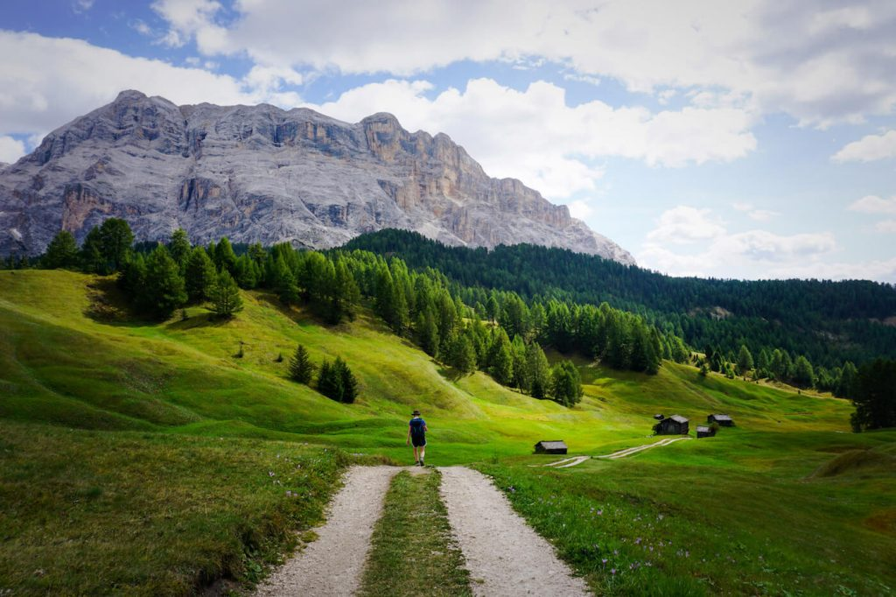

beneath, prominent, enchanting,

The Armentara Meadows (Prà de Armentara in Ladin, Armentarawiesen in German, Prati dell’Armentara in Italian) are located …beneath………………. the rock face of Sasso di Santa Croce (Sas dla Crusc in Ladin, Heiligkreuzkofel in German), a prominent mountain in the Fanes Group.

Sprawling across the western edge of the Fanes-Senes-Braies Nature Park between 1600 and 2000 meters, this …enchanting…………………………. place can easily be reached from Badia, or La Villa, in Val Badia.

We wrote about how to get here from Badia in this easy [Armentara Meadows day hike](https://www.moonhoneytravel.com/la-crusc-armentara-hike-badia-dolomites/) starting at Rifugio Santa Croce/La Crusc.

11. Cortina d’Ampezzo

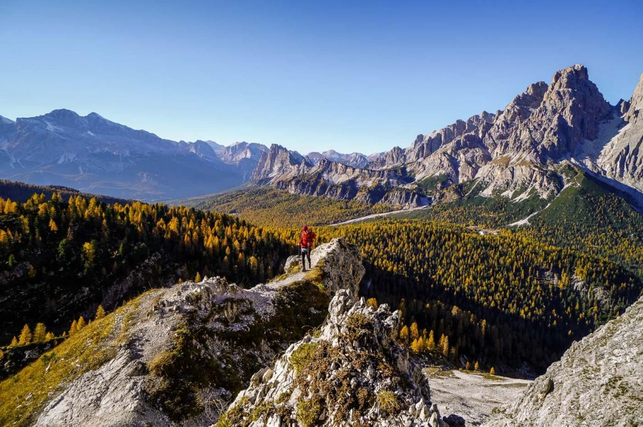

Cortina d’Ampezzo is a famous ski resort town in Ampezzo Valley in the Italian Province of Belluno in the region Veneto.

Cortina’s central location in the Ampezzo Dolomites means easy access to the Sorapiss Group, Tofane Group, Croda da Lago Group, Cristallo Group, and even the Sexten Dolomites.

It also means that Cinque Torri, Lagazuoi Tunnels, Rifugio Lagazuoi, Rifugio Nuvolau, Passo Giau, Lago Federa, Lago di Sorapis, [Tofana di Rozes](https://www.moonhoneytravel.com/hiking-tofana-di-rozes-circuit-trail/)**,** Tre Cime di Lavaredo, and other top Dolomites attractions are within reach.

Cortina d’Ampezzo is justifiably popular, and so, we recommend visiting in Autumn, when the crowds have died down and the trails are blissfully empty.

The best places to stay in Cortina are [Jaegerhaus Agriturismo](https://www.booking.com/hotel/it/jagerhaus-agriturismo.en.html?aid=1433540&no_rooms=1&group_adults=2&room1=A%2CA) (budget),[Camina Suite & Spa](https://www.booking.com/hotel/it/myriam.en.html?aid=1433540&no_rooms=1&group_adults=2&room1=A%2CA) (midrange), or[Dolomiti Lodge Alverà](https://www.booking.com/hotel/it/dolomiti-lodge-alvera.en.html?aid=1433540&no_rooms=1&group_adults=2&room1=A%2CA) (luxury).

Read our guide to [visiting Cortina d’Ampezzo](https://www.moonhoneytravel.com/cortina-d-ampezzo-italy/).

12. Lago Federa

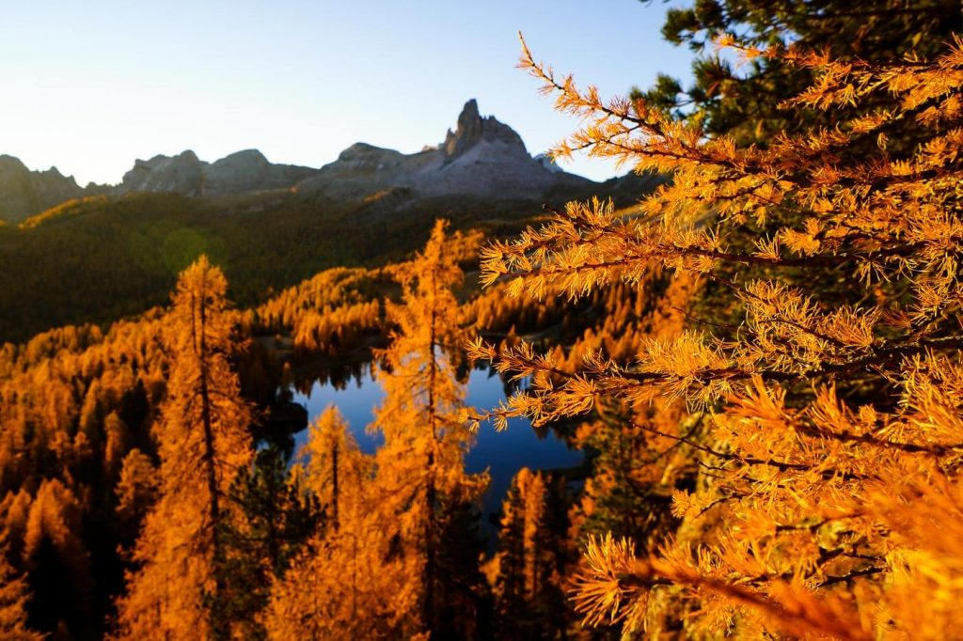

picturesque, larches, solitary,

Lago Federa (Lago di Federa, Lago Fedèra, Lake Federa) is a …picturesque………………………mountain lake beneath the eastern wall of Croda da Lago in the Ampezzo Dolomites, southwest of Cortina d’Ampezzo.

From Lake Federa’s northern shore, the elegant and …solitary…………………. Becco di Mezzodi looks like it’s twisting up from a carpet of forest. This magical scene is one of the most popular photo motifs in the Dolomites, especially in late October, when the …larches……………. turn golden.

The lake is located along the superb[Croda da Lago Circuit Trail,](https://www.moonhoneytravel.com/croda-da-lago-circuit-hike/) which is one of the [best day hikes in the Dolomites](https://www.moonhoneytravel.com/best-day-hikes-dolomites-italy/).

Learn more about this must-see lake in our [Lake Federa guide](https://www.moonhoneytravel.com/lago-federa-rifugio-croda-da-lago/).

If you want to catch sunrise at Lago Federa, either stay the night in the lakeside hut, Rifugio Croda da Lago/Palmieri, or in the budget-friendly guesthouse [Hotel Piccolo Pocol](https://www.booking.com/hotel/it/piccolo-pocol.en.html?aid=1433540&no_rooms=1&group_adults=2&room1=A%2CA) in Pocol, a hamlet above Cortina d’Ampezzo.

13. Tre Cime di Lavaredo

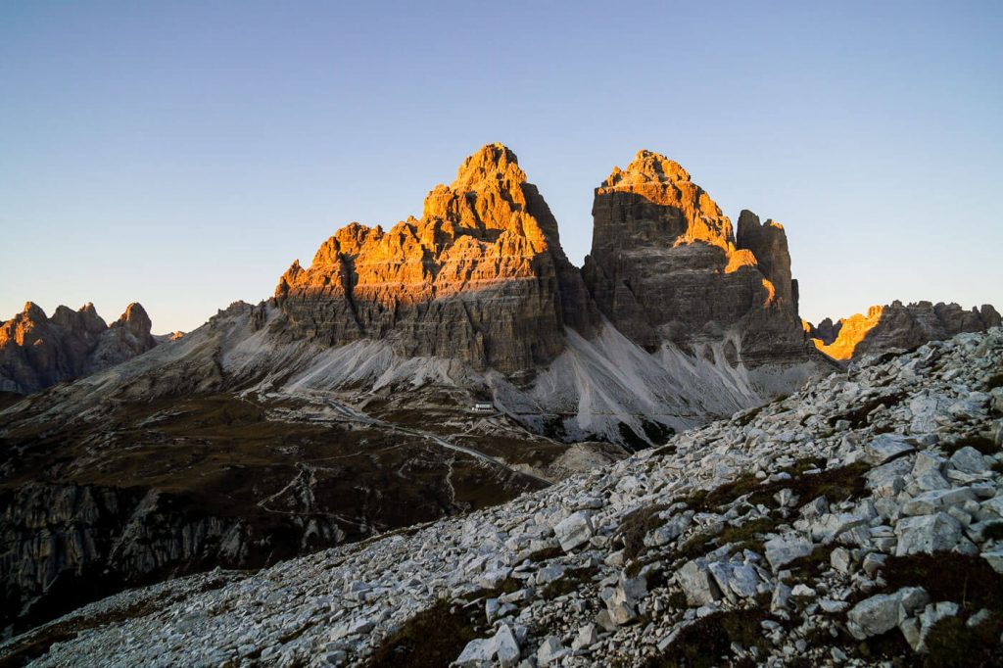

**fortifications, straddle,**

Tre Cime di Lavaredo (Drei Zinnen in German, Three Peaks in English) is the name given to three mammoth peaks in the **Sesto/Sexten Dolomites**.

The Three Peaks …straddle…………………… the border between Italian-speaking Belluno and German-speaking South Tyrol.

Until 1919, Tre Cime di Lavaredo formed part of the border between Italy and the Austro-Hungarian Empire. During the First World War, the front line between Italy and Austria-Hungary ran through the Tre Cime di Lavaredo peaks. Today, you can still see …fortification……………………., trenches, iron ladders, tunnels and other relics of war from that era.

The easiest way to see the Three Peaks is by driving the [Tre Cime – Rifugio Auronzo toll road](https://www.moonhoneytravel.com/rifugio-auronzo-toll-road/)from Lago d’Antorno to Rifugio Auronzo. This road is only open seasonally from late May/early June until late October/early November, depending on snow/ice conditions.

From the Auronzo hut, we recommend hiking the beloved [Tre Cime di Lavaredo Circuit Trail.](https://www.moonhoneytravel.com/tre-cime-di-lavaredo-hike/) This 9.7 km-long trail takes about 4 hours to complete. Along the trail, you’ll pass Malga Langalm, Rifugio Locatelli/Dreizinnenhütte, and Rifugio Lavaredo.

14. Cadini di Misurina

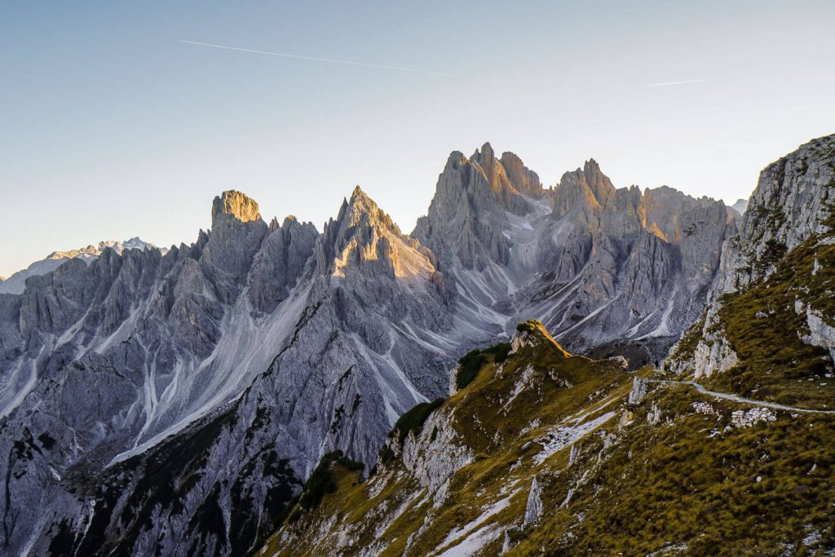

**spires, jagged, traverse, encompasses**

Cadini di Misurina is a gorgeous mountain group in the province of Belluno. Defined by sharp, slender …spires……………….., the …jagged……………… Cadini mountains look like the backdrop of a high fantasy epic.

They form the southernmost mountain group of the Sexten Dolomites, the same range that …encompasses………………….. Tre Cime di Lavaredo.

Experienced hikers can …traverse……………… the Cadini Group along the [Sentiero Bonacossa Trail](https://www.moonhoneytravel.com/sentiero-alberto-bonacossa-north-trail/), an aided path that starts at Rifugio Col de Varda and ends at Rifugio Auronzo.

The best view of the Cadini Group is from the [Cadini di Misurina Viewpoint,](https://www.moonhoneytravel.com/cadini-di-misurina-viewpoint-hike/) often lovingly called the Towers of Mordor. You can walk to this viewpoint from Rifugio Auronzo in 30 minutes.

15. Lago di Sorapis

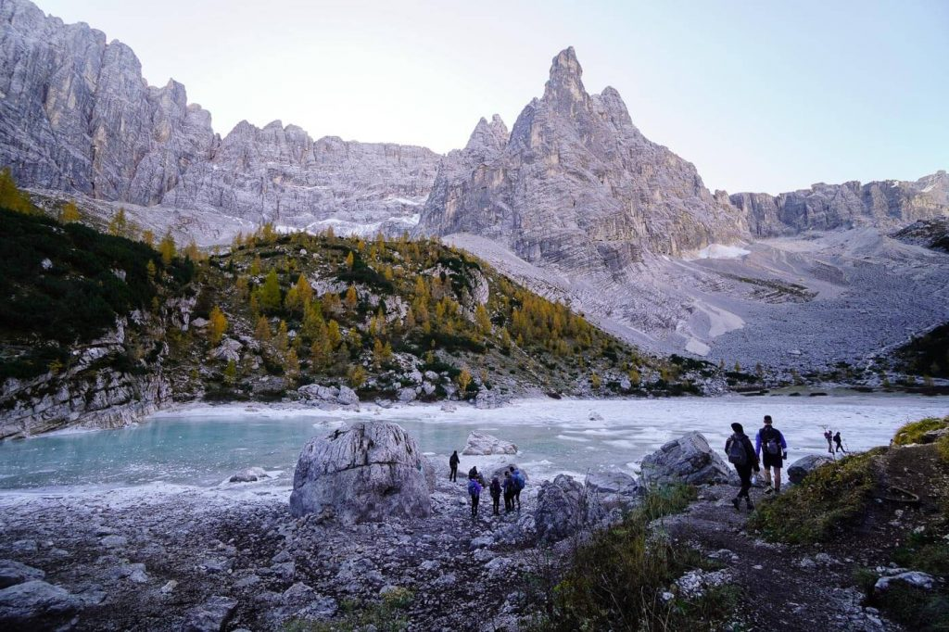

**glacial , detract, turquoise, swarming**

Lago di Sorapis (also spelled Lago di Sorapiss) is a …glacial……………………. lake in the Sorapiss Group in Belluno.

Renowned for its milky …turquoise……………….. color and dramatic location at the foot ofDito di Dio (“Finger of God”), Lake Sorapis is …swarming……………… with visitors each hiking season.

Lake Sorapis is only accessible by foot. Starting at Passo Tre Croci, the mountain pass between Cortina and Lake Misurina, it takes 2 hours to hike to the lake.

Though the trail is beautiful and interesting, the sheer amount of people …detract………………………. from the experience. Avoid hiking here on weekends and in August.

For a comprehensive guide to hiking to Lake Sorapis, read our [Lago di Sorapis Trail Guide](https://www.moonhoneytravel.com/lago-di-sorapis-hike/).

16. Mondeval Plateau

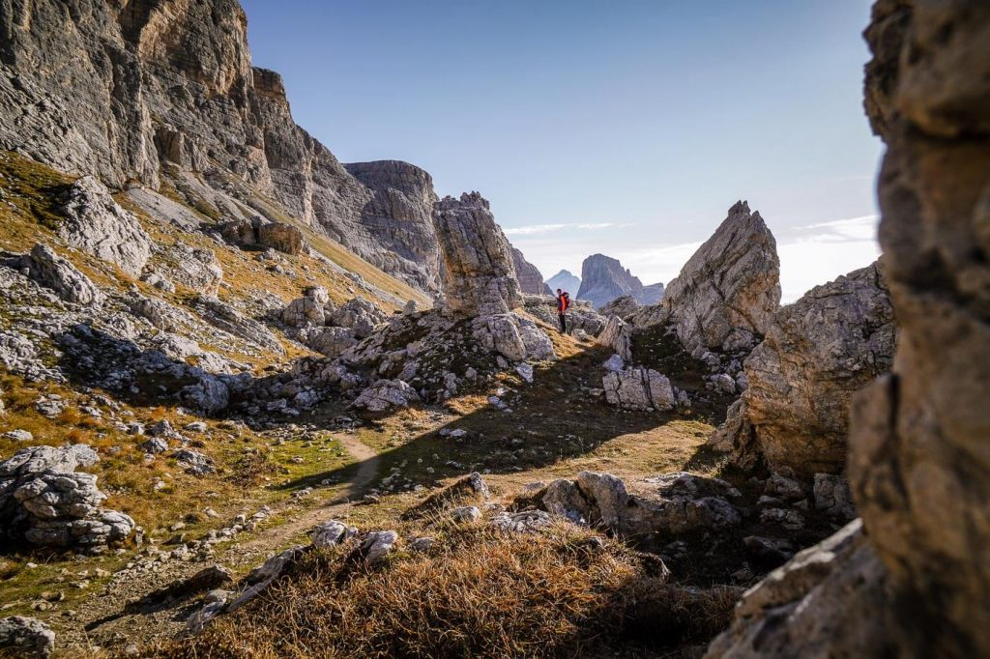

**municipality, panoramic, burial, stellar,**

Mondeval is a bowl-shaped plateau in the …municipality……………………. of San Vito di Cadore within the [Dolomites](https://www.moonhoneytravel.com/europe/italy/dolomites/) UNESCO System Pelmo – Croda da Lago. Its height ranges from 2100 to 2360 meters.

The Mondeval basin is home to the archeological …burial……………. site of Mondeval de Sora, the tiny [Lago delle Baste](https://www.moonhoneytravel.com/lago-delle-baste-mondeval-plateau/) lake, and the Monte Mondeval …stellar…………………….. peak.

We love visiting Mondeval, because the high plateau affords …panoramic………………..views of Monte Pelmo and Lastoni di Formin.

We recommend this easy-moderate[hike to Mondeval starting at Passo Giau](https://www.moonhoneytravel.com/passo-giau-monte-mondeval-day-hike/), the mountain pass between Pocol (Cortina d’Ampezzo) and Selva di Cadore.

17. San Martino di Castrozza

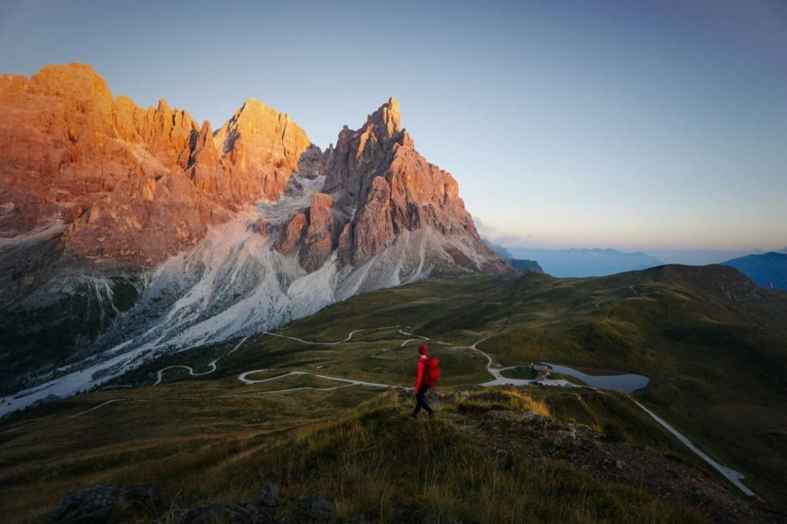

**stunning, dazzling, cradled,**

San Martino di Castrozza is a resort town in Primiero Valley in the Italian Province of **Trentino**.

The town center is …cradled………………. by the steep walls of the **Pale di San Martino Group** (aka Pala Group) and the Lagorai mountain range.

By the way, Pale di San Martino is the largest mountain group in the entire Dolomites.

And, San Martino di Castrozza is (in our opinion) the most visually …dazzling………………….. town in the Dolomites. Fortunately, very few non-Italians venture here.

Base yourself in San Martino di Castrozza for a few days, and you can explore the moon-like landscapes of the Altopiano delle Pale di San Martino plateau, the alpine pastures of Val Venegia and Val Canali, and the …stunning………………………. views around Passo Rolle and Baita Segantini.

18. Altopiano delle Pale di San Martino

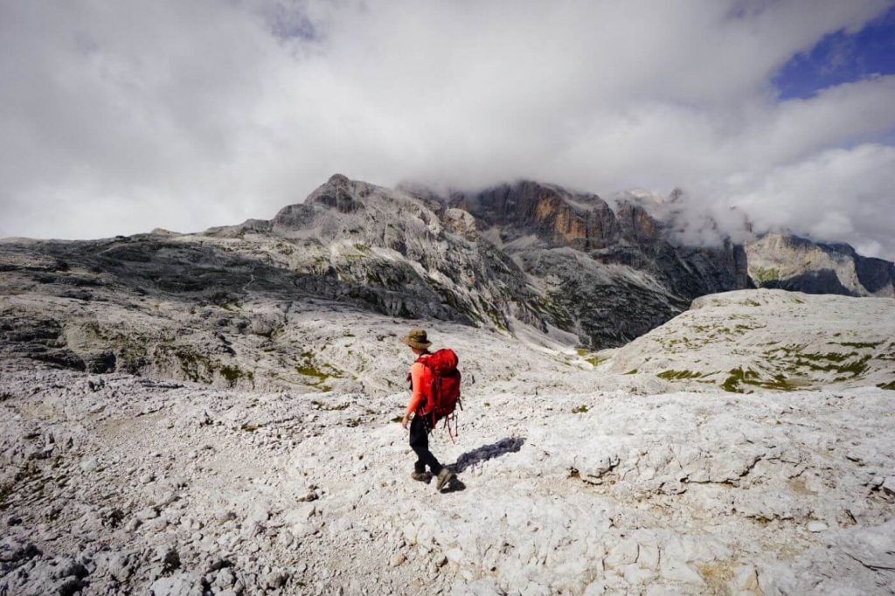

**vast, elevation, undertaken, ascend, enormous,**

Altopiano delle Pale di San Martino is a……vast……………….., karst plateau in the Pale di San Martino mountain group. It covers an …enourmous………………… surface area of about 50 km².

Ranging between 2500 to 2800 meters in …elevation………………………, this high-alpine lunar landscape is a fascinating place to explore.

From San Martino di Castrozza, you can easily …ascend………………… to the plateau by cableway (Colverde Gondola followed by the Rosetta Cable Car).

We visited the Pale di San Martino plateau twice. During our first visit, we hiked the circuit trail around Pala di San Martino, from [Rifugio Rosetta to Rifugio Pradidali](https://www.moonhoneytravel.com/rifugio-pradidali-rifugio-rosetta-pale-di-san-martino-hike/). This is a fantastic hike, which should only be …undertaken……………………on clear days.

We also ascended to the Pala plateau to hike to [Cima della Vezzana](https://www.moonhoneytravel.com/hiking-cima-della-vezzana-pale-di-san-martino-dolomites/), the highest peak in the Pale di San Martino mountains. That was a tough one.

19. Val Venegia

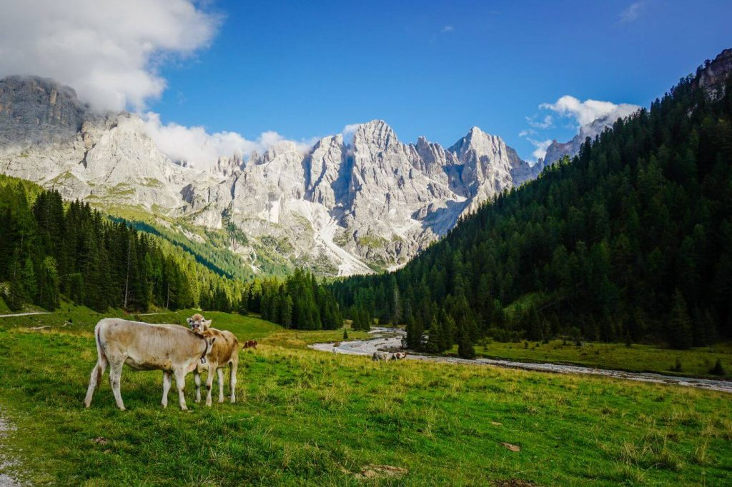

Val Venegia is a fairy-tale-like valley, located between Passo Rolle and Passo Valles in Trentino. The closest towns are San Martino di Castrozza and Predazzo.

There are so many ways to enjoy Val Venegia. You can walk the valley trail, eat lunch at a Malga (alpine pasture hut), or hike up into the Pale di San Martino mountains.

We hiked a circuit route from Val Venegia to Rifugio Mulaz and it’s one of the best day hikes in the Dolomites we’ve experienced to date.

We’ve explained how to get to Val Venegia, where to park, and where to eat in our [Val Venegia – Rifugio Mulaz trail guide](https://www.moonhoneytravel.com/val-venegia-malga-venegiota-rifugio-mulaz-hike-dolomites/).

20. Baita Segantini

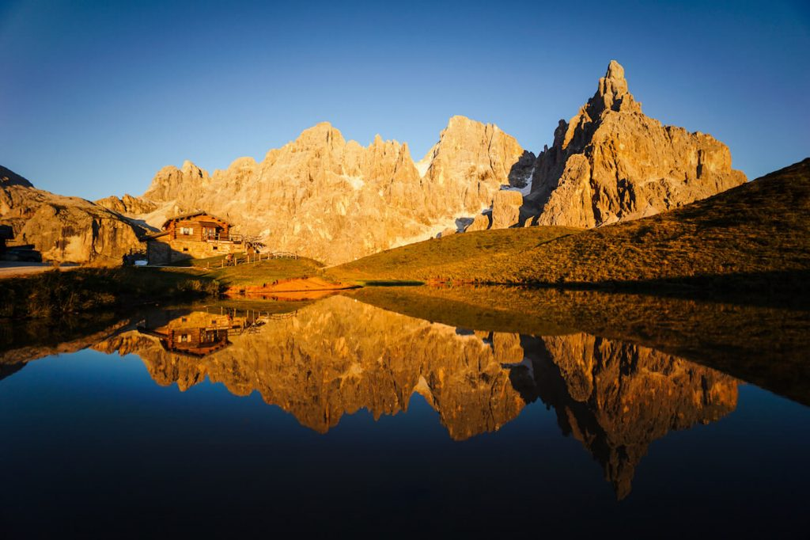

[Baita Segantini](https://www.baitasegantini.it/) is an alpine pasture hut facing the northern side of the Pale di San Martino group, including the majestic Cimon Della Pala. It’s one of the most beautiful destinations in the Dolomites, especially at sunset when the Pale peaks light up in fiery hues of violet, blood-orange, and crimson.

From the Passo Rolle mountain pass, we recommend hiking to Baita Segantini via Monte Castellaz summit. The full-circuit takes 3:30 hours.